**UNIT -I**

**Healthcare data, information and knowledge**

**Introduction**

the growth in the volume of medical knowledge and patient information that has occurred due to better understanding of human health has resulted in more treatments and interventions that produce more information. Likewise, the increase in specialization has also created the need to share and coordinate patient information. With the advent of the internet, high speed computers, voice recognition, wireless and mobile technology healthcare professionals today have many more tools available at their disposal. However, in general, technology is advancing faster than healthcare professionals can assimilate it into their practice of medicine.

Health Informatics is a rapidly evolving field that intersects information science, computer science, and healthcare. It focuses on the effective use of biomedical data, information, and knowledge for scientific inquiry, problem-solving, and decision-making aimed at improving human health. This field is crucial for managing the vast amounts of data generated by the healthcare industry, which is expected to continue growing significantly. Approximately 30% of the world's data comes from the healthcare sector, and this percentage is projected to rise to 36% by 2025. Despite the importance of data in healthcare, a significant portion of it is not utilized for making informed business decisions, highlighting the need for better data management and analytics within healthcare organizations.

Health Informatics encompasses several specialized areas, including:

* Public Health Informatics: Focuses on using information technology to educate the public and track current medical research. It involves designing and implementing new methods in the field.
* Organizational Informatics: Studies communication within medical organizations and the collection of data used by these organizations.
* Social Informatics: Investigates the social implications of computerization and how information technology affects society's perception of these systems.
* Clinical Informatics: Examines how information technology impacts clinical research and medical education, aiming to improve patient outcomes and advance medical research.

The field of Health Informatics is driven by the need for evidence-based medicine, quality improvement, data security, and patient accessibility. It plays a critical role in controlling and addressing public health concerns through the use of interprofessional teams. The future of Health Informatics looks promising, with advancements in technology and increasing investments in healthcare systems expected to enhance public healthcare accessibility and reliability.

Health Informatics is not just about technology; it's about how effectively technology is integrated into existing cultures, regulatory frameworks, and institutional workflows to improve healthcare delivery. The successful evolution of healthcare is determined by the integration of technology into these aspects, rather than solely by the technological capabilities themselves. This integration is crucial for advancing medical research, improving patient outcomes, and increasing the value of healthcare delivery.

**Healthcare data, information and knowledge:**

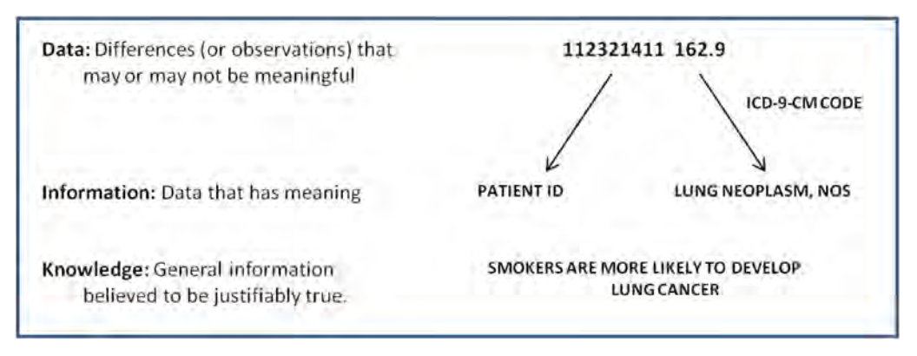

**Data**

To understand the relationship between data, information and knowledge in health informatics, readers must understand the relationship between what happens in a computer and the real world. Computers do not represent meaning. They input, store, process and output zero (off) and one (on). Each zero or one is known as a bit. A series of eight bits is called a byte. Bits within computers are aggregated into a variety of data types.

• Integers such as 32767, 15 and -20

• Floating point numbers (or floats) such as 3.14159, -12.014, and 14.01; the floating point refers to the decimal point

• Characters “a,” and “z”

• (Character) Strings such as “hello” or “ball”

Data can be aggregated into a variety of file formats. These file formats specify the way that data are organized within the file

• Image files such as JPG, GIF and PNG.

• Text files

• Sound files such as WAV and MP3

• Video files such as MPG

**Knowledge**

Healthcare knowledge management is a strategic approach to organizing, sharing, and utilizing the collective wisdom of healthcare professionals to improve patient care and operational efficiency. It involves creating, capturing, and disseminating knowledge through various channels, such as knowledge bases, wikis, and collaborative platforms. Knowledge management systems are used to store and share information on best practices, research findings, and patient care protocols, enabling healthcare professionals to learn from each other and continuously improve their skills and services.

**Information**

Healthcare information management goes beyond data management by focusing on the interpretation and application of data to inform healthcare delivery. This includes the use of EHRs, clinical decision support systems, and other tools that help healthcare providers access and utilize relevant information to diagnose, treat, and manage patient conditions. Information management systems are designed to facilitate the retrieval, analysis, and dissemination of information to support clinical practice, research, and administrative functions.

**Converting Data to Information to Knowledge**

In order to perform useful computation, a conceptual model must be created, which selectively represents relevant aspects of the real world. The conceptual model is used to design a computational model, which is what the computer manipulates. Everything not included in the conceptual model is assumed to be irrelevant for the computation.

Data must be represented in a format that can be processed by computers. Formal methods manipulate data based on systematic rules, focusing only on the form of the data, not their meaning. Humans are responsible for ensuring that the input and output of formal methods correctly capture and preserve meaning.

An example is provided where a formal method (division) can yield an inappropriate answer if critical constraints from the real world are omitted from the conceptual model. It's emphasized that while computers may not malfunction in such cases, the answers obtained may not be useful if the computational model does not align with the real-world context.

Data become information when meaning is assigned to them. For example, a numerical code like "162.9" becomes meaningful when interpreted as "Lung neoplasm, not otherwise specified" through a vocabulary like ICD-9-CM.

Information serves as the basis for generating knowledge. Knowledge represents justified, true beliefs derived from meaningful data. Methods in informatics aim to transform clinical information into knowledge, often through techniques like clinical data warehouses and research informatics.

**Clinical data warehouse**

Increasingly, clinical data are collected via electronic health records (EHRs). Clinical records within EHRs are composed of both structured data and unstructured or (free text). Structured data may include billing codes, lab results, problem lists, medication lists, etc.

structured data is much easier to manage – it is computationally tractable. Ideally, but not always, these data are encoded using a standard such as ICD-9-CM. Thus, retrieving patients with a particular problem is, theoretically, simply a matter of identifying all records that are tagged with a particular code.

Free text, on the other hand, has the advantage of being able to express anything that can be expressed using natural language. On the other hand, it is difficult for computers to process. Indeed, the field of natural language processing (NLP) is an active area of research in both computer science and informatics. Within clinical records, the free text notes are critically important.

CDWs are increasingly valuable for quality monitoring, clinical and translational research, comparative effectiveness research (CER), and public health surveillance. They enable researchers and healthcare professionals to analyze trends, track pathogens, and conduct research on real-world clinical data.

One prominent CDW platform is i2b2, developed by the Informatics for Integrating Biology and the Bedside project. It utilizes a star schema composed of facts and dimensions to organize clinical data for research and quality monitoring purposes.

To fully harness the potential of CDWs, it's essential to turn raw data into meaningful information and knowledge. This involves extracting relevant concepts from unstructured data, classifying records, and utilizing advanced analytics techniques.

**…under the assumption that laws of medical informatics exist, I would like to nominate the first law: Data shall be used only for the purpose for which they were collected. This law has a collateral: If no purpose was defined prior to the collection of the data, then the data should not be used.**

To make sense of clinical records, both structured data and free text must be leveraged. This remains an active area of informatics research.

A clinical data warehouse is a shared database that collects, integrates and stores clinical data from a variety of sources including electronic health records, radiology and other information systems. EHRs are designed to support realtime updating and retrieval of individual data. Data from multiple sources including one or more EHRs are copied into a staging database, cleaned and loaded into a common database where they are associated with meta-data. Meta-data are data that describe other data.

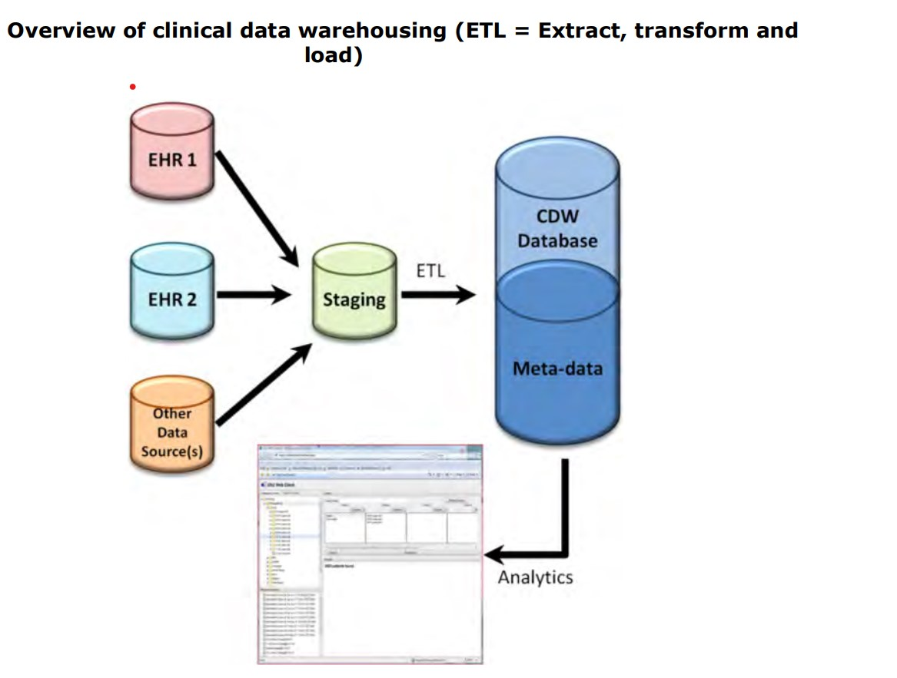

**Data analytics**

The growth of such data has increased dramatically in recent years due to incentives for EHR adoption in the US funded by the Health Information Technology for Economic and Clinical Health (HITECH) Act. there has also seen substantial growth in other kinds of health-related data, most notably through efforts to sequence genomes and other biological structures and functions. The analysis of this data is usually called analytics (or data analytics).

• Descriptive – standard types of reporting that describe current situations and problems

• Predictive – simulation and modeling techniques that identify trends and portend outcomes of actions taken

• Prescriptive – optimizing clinical, financial, and other outcomes

A core methodology in data analytics is machine learning, which is the area of computer science that aims to build systems and algorithms that learn from data.8 One of the major techniques of machine learning is data mining, which is defined as the processing and modeling of large amounts of data to discover previously unknown patterns or relationships. 9 A subarea of data mining is text mining, which applies data mining techniques to mostly unstructured textual data. 10 Another close but more recent term in the vernacular is big data, which describes large and ever-increasing volumes of data that adhere to the following attributes:

• Volume – ever-increasing amounts

• Velocity – quickly generated

• Variety – many different types

• Veracity – from trustable sources

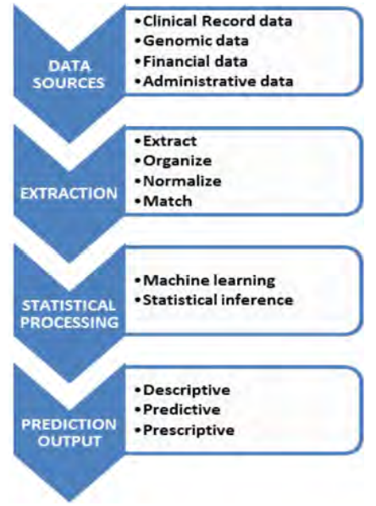

The pipeline begins with input data sources, which in healthcare and biomedicine may include clinical records, financial records, genomics and related data, and other types, even those from outside the healthcare setting (e.g., census data). The next step is feature extraction, where various computational techniques are used to organize and extract elements of the data, such as linking records across sources, using natural language processing (NLP) to extract and normalize concepts, and matching of other patterns. The final step is the output of predictions, often with probabilistic measures of confidence in the results.

The growing quantity of data requires that its users have a good understanding of its provenance, which is where the data originated and how trustworthy it is for large-scale processing and analysis. A number of researchers and thought leaders have started to specify the path that will be required for big data to be applied in healthcare and biomedicine

A more peripheral but related term is business intelligence, which in healthcare refers to the “processes and technologies used to obtain timely, valuable insights into business and clinical data”. Another relevant term is the notion promoted by the Institute of Medicine of the learning health system. Another set of related terms come from the call for new and much more data-intensive approaches to diagnosis and treatment of disease variably called personalized medicine, precision medicine, or computational medicine

**Challenges**

Data generated in routine patient care may be inaccurate, incomplete, or transformed in ways that undermine its meaning (e.g., for billing purposes). Statistical phenomena like censoring (both left and right) may affect the accuracy and completeness of the data. Adherence to standards may be incomplete, making it difficult to combine data from different sources. Clinical data mostly allows for observational studies rather than experimental ones, which raises issues about determining cause and effect. Research questions are often driven by what can be answered with available data rather than prospective hypotheses. Data may not always be as objective as desired, and simply having more data (i.e., bigger data) does not necessarily lead to better outcomes. Ethical concerns exist regarding data collection, use, and access, as well as potential disparities between those who have access to data and those who do not. Neff highlights technical, financial, and ethical issues that must be addressed before big data can be routinely used for clinical practice and other health-related purposes. These challenges also give rise to ethical questions regarding data ownership and who has the privilege to use it.

**Role of informatics in analytics**

Data science is more than statistics or computer science applied in a specific subject domain. Dhar notes that a key aspect of data science, in particular what distinguishes it from statistics, is an understanding of data, its varying types, and how to manipulate and leverage it.80 He points out that skills in machine learning are key, based upon a foundation of statistics (especially Bayesian), computer science (representation and manipulation of data), and knowledge of correlation and causation (modeling). Dhar also notes a challenge to organizational culture that might occur as organizations moved from “intuition-based” to “fact-based” decisionmaking.

It is also clear that there are two types of individuals working with analytics and big data. A report by the McKinsey consulting firm states that there will soon be a need in the US for 140,000-190,000 individuals who have “deep analytical talent”. Furthermore, the report notes there will be need for an additional 1.5 million “data-savvy managers needed to take full advantage of big data”. Analyses from the UK find similar results. An analysis by SAS estimated that by 2018, there will be over 6400 organizations that will hire 100 or more analytics staff.84 Another report found that data scientists currently comprise less than 1% of all big data positions, with more common job roles consisting of developers (42% of advertised positions), architects (10%), analysts (8%) and administrators (6%). 85 It was also found that the technical skills most commonly required for big data positions as a whole were NoSQL, Oracle, Java and SQL. While these estimates are not limited to healthcare, they also do not include other countries that will have comparable needs to the US and the UK for such talent. A report from IBM Global Services noted healthcare organizations are lagging behind in hiring individuals who are proficient in both “numerate” and business-oriented skills. An additional report from IBM Global Services list “expertise” among the critical attributes in organizations that are needed to complement technology. This expertise includes the supplementation of business knowledge with analytics knowledge, establishing formal career paths for analytics professionals, and tapping partners to supplement skills gaps that may exist. Another US-based report by Price Water house Coopers on health IT talent shortages noted that healthcare organizations wanting to keep ahead needed to acquire talent in Systems and data integration, data statistics and analytics, technology and architecture support, and clinical informatics.

The US National Institutes of Health (NIH) also recognizes that big data skills will be important for conducting biomedical research. In 2013, NIH convened a workshop on enhancing training in big data among researchers. Similar to the healthcare domain, participants called for skills in quantitative sciences, domain expertise, and ability to work in diverse teams. The workshop also noted a need for those working in big data to understand concepts of managing and sharing data. Trainees should also have access to real-world data problems and real-sized data sets to solve them. Longer-term training would be required for those becoming experts and leaders in data science.

1. Programming - especially with data-oriented tools, such as SQL and statistical programming languages

2. Statistics - working knowledge to apply tools and techniques

3. Domain knowledge - depending on one's area of work, bioscience or health care

4. Communication - being able to understand needs of people and organizations and articulate results back to them

**Future trends**

• Adherene to best practices for use of data standards and interoperability

• Processes to evaluate availability, completeness, quality, and transformability of data

• Toolkits and pipelines to manage data and its attributes

• Challenges and metrics for assessing “research grade” of operational data

• Standardized reporting methods for operational data and its attributes

• Adaptation of “best evidence” approaches to use of operational data

• Appropriate use of informatics expertise to assist with optimal use of operational data and to develop published guidelines for doing so

• Research agenda to determine biases inherent in operational data and to assess informatics approaches to improve data

**UNIT -II**

**Electronic health records**

**Introduction**

The American Recovery and Reimbursement Act (ARRA) of 2009 was a major game changer for electronic health records, with reimbursement by Medicare and Medicaid for the Meaningful Use of certified EHRs. EHRs are also known as electronic medical records (EMRs), computerized medical records (CMRs), electronic clinical information systems (ECIS) and computerized patient records (CPRs). In 2008 the National Alliance for Health Information Technology released the following definitions in an effort to standardize terms used in HIT: Electronic Medical Record: “An electronic record of health-related information on an individual that can be created, gathered, managed and consulted by authorized clinicians and staff within one healthcare organization.”9 Electronic Health Record: “An electronic record of health-related information on an individual that conforms to nationally recognized interoperability standards and that can be created, managed and consulted by authorized clinicians and staff across more than one healthcare organization.” Personal Health Record: “An electronic record of health-related information on an individual that conforms to nationally recognized interoperability standards and that can be drawn from multiple sources while being managed, shared and controlled by the individual.

Clinical decision support systems (CDSS) to include alerts, reminders and clinical practice guidelines. CDSS is associated with computerized physician order entry (CPOE). This will be discussed in more detail in this chapter and the patient safety chapter.

• Secure messaging (e-mail) for communication between patients and office staff and among office staff. EHRs will likely include messaging that is part of the Direct Project, explained in the chapter on health information exchange. Telephone triage capability is important.

• An interface with practice management software, scheduling software and patient portal (if present). This feature will handle billing and benefits determination. This will be discussed further in another section.

• Managed care module for physician and site profiling. This includes the ability to track Health plan Employer Data and Information Set (HEDIS) or similar measurements and basic cost analyses.

• Referral management feature

• Retrieval of lab and x-ray reports electronically

• Retrieval of prior encounters and medication history

• Computerized Physician Order Entry (CPOE). Primarily used for inpatient order entry but ambulatory CPOE also important. This will be discussed in more detail later in this chapter.

• Electronic patient encounter. One of the most attractive features is the ability to create and store a patient encounter electronically. In seconds one can view the last encounter and determine what treatment was rendered.

• Multiple ways to input information into the encounter should be available: free text (typing), dictation, voice recognition and templates.

• The ability to input or access information via a smartphone or tablet PC

• Remote access from the office, hospital or home

**scope for the e health records**

Handwritten records are often illegible, unstructured, and cannot be electronically shared or stored efficiently. Paper records are expensive to copy, transport, and store, and they pose environmental concerns. Retrieval of information from paper records is slower, and missing or incomplete information is common.

EHRs offer legibility, rapid retrieval, and organization of patient data. They reduce the need for physical storage space and the labor required to manage paper records. EHRs improve accessibility to patient information, allow simultaneous access by multiple healthcare workers, and provide 24/7 availability. They facilitate better coding, reduce redundant paperwork, and enhance productivity through features like clinical decision support and templates. EHRs improve patient safety by reducing errors, facilitating reminders, and providing comprehensive problem summary lists. EHRs improve patient safety through various mechanisms like legibility, access to information, reminders, and decision support. However, some studies have failed to demonstrate significant improvements in quality measures post-EHR implementation. EHRs are expected to generate significant cost savings by reducing transcription costs, avoiding duplicated tests, and improving coding and billing accuracy.

They enhance productivity through faster access to information, streamlined workflows, and integrated features like templates and decision support. Advancements in technology, such as the internet, digital imaging, and mobile technologies, make EHR adoption feasible and beneficial. EHRs facilitate integration with other services, data analytics, and decision-making tools, thereby enhancing healthcare delivery and outcomes. EHRs enable the aggregation of data from multiple sources, which is essential for evidence-based decision-making and statistical significance.

They allow for integration with various applications and services, both internal and external, improving care coordination and healthcare reform efforts. EHR adoption is seen as transformational for healthcare, driving improvements in quality, efficiency, and population health management. Organizations like Kaiser Permanente have demonstrated the potential of EHRs to enhance disease management, standardization of care, and data analytics.

EHRs play a crucial role in facilitating communication and coordination of care among multiple healthcare providers, particularly in complex healthcare systems.

**Challenges**

The challenges of Electronic Health Record (EHR) adoption and achieving meaningful use are multifaceted and include financial barriers, physician resistance, loss of productivity, workflow changes, reduced physician-patient interaction, usability issues, integration with other systems, quality reporting issues, lack of interoperability standards, privacy concerns, legal aspects, inadequate proof of benefit, patient safety concerns, and unintended consequences.

Usability issues, integration with other systems, and quality reporting present additional hurdles, as EHR systems need to be intuitive, interoperable, and capable of generating accurate quality reports. Privacy concerns, legal aspects, and the lack of proof regarding the benefits of EHRs further complicate adoption efforts. Patient safety is a paramount concern, with the potential for unintended consequences such as increased errors and alert fatigue.

Addressing these challenges requires a multifaceted approach, including improved usability, interoperability standards, robust training programs, and ongoing research to evaluate the impact of EHRs on healthcare outcomes. Additionally, efforts to mitigate patient safety risks and unintended consequences are essential to ensure that EHR adoption ultimately improves the quality, efficiency, and safety of healthcare delivery.

1. **Financial Barriers**: EHR adoption is expensive, with significant initial costs ranging from $14,000 to $63,000 per FTE provider, along with ongoing annual costs of $8,500 per FTE. However, benefits, especially from improved coding, can offset some of these costs.
2. **Physician Resistance**: Lack of support from medical staff has been a significant obstacle to EHR adoption. Physicians need to see clear benefits such as saving time, making money, or benefiting patients.
3. **Loss of Productivity**: Implementing EHRs can lead to reduced productivity initially, with a gradual improvement over time depending on training and workflow adjustments.
4. **Workflow Changes**: Transitioning from paper-based systems to EHRs requires significant workflow changes for all staff members, affecting processes like chart management and patient scheduling.
5. **Reduced Physician-Patient Interaction**: Concerns exist that EHR usage may detract from direct physician-patient interaction. Efforts are needed to maintain eye contact and integrate EHR use seamlessly into patient visits.
6. **Usability Issues**: EHR software should be well-organized and intuitive, but usability varies among different specialties and users. Efforts are being made to ensure EHRs pass usability testing.
7. **Integration with Other Systems**: Integrating EHRs with other systems like practice management software can be costly and complex, requiring significant programming work.
8. **Quality Reporting Issues**: EHRs can generate data necessary for quality reporting, but challenges exist in ensuring accuracy and improvement in overall quality, as seen in some studies.
9. **Lack of Interoperability Standards**: Data standards and medical vocabularies are essential for interoperability, but challenges remain in ensuring EHRs can exchange information effectively.
10. **Privacy Concerns**: EHRs raise new privacy and security threats, but proper technology and user behavior can mitigate these risks. EHRs offer new safeguards like audit trails and encryption.
11. **Legal Aspects**: EHRs may impact malpractice liability, with potential benefits in improving documentation quality but also risks related to errors and liability for overlooking information.
12. **Inadequate Proof of Benefit**: While some studies show benefits of EHR implementation, others fail to demonstrate significant impacts on medical quality or cost-effectiveness.
13. **Patient Safety and Unintended Consequences**: EHR implementation can lead to unintended consequences such as increased errors and alert fatigue. Efforts are being made to address these issues through better training and design.
14. **Reliability**: Despite successful implementations, EHRs have experienced dramatic failures, highlighting the need for backup plans and system reliability.

**Examples**

**Small Medical Practice**

* Features: Offers a simple and intuitive EHR, ONC ATCB certified, high usability, three-month free trial, subscription-based service, includes scheduling, secure messaging, charting, e-prescribing, billing, ad hoc reporting, remote access.
* Pricing: Standard charge of $1,995 per physician for the first year, followed by $995 per physician per year for software updates and tech support. Additional fees for offsite backup and interfaces.

**Medium Size Medical Practice**

* Features: Multi-featured EHR, well-designed, high physician acceptance, fully integrated modules, web-based and client-server options, EMR module with various data input methods, practice management, patient portal, clinical messenger, interoperability, care coordination, mobile access.
* Pricing: Cloud-based EHR starts at $375/month/clinician, EHR-only package at $499/clinician/month, combined EHR/PMS system at $599/clinician/month. Revenue cycle management option available.

**Large to Very Large Medical Practice**

* Features: Comprehensive EHR for large healthcare organizations, ambulatory and inpatient options, specialty-specific workflow, extensive modules including practice management, personal health record (PHR), information exchange, physician portal, interoperability, mobile access.
* Pricing: Varied pricing structure, not openly disclosed, typically tailored to the specific needs and size of the organization.

**logical steps to selecting and implementing EHR**

EHR implementations are complex affairs. They are not simply IT projects. They are practice transformation projects that should be considered socio-technical-economic initiatives. If approached as simply software to be installed and users to be trained in using the software, an EHR implementation will undoubtedly falter or even fail. Thus, health care organizations involved in implementing an EHR are wise to spend a lot of time planning.

Implementation of an EHR can be divided into three separate, yet intertwined phases : Pre-implementation, implementation and postimplementation. While each phase is distinct, the success of subsequent phases depends upon the thorough planning and execution of the prior stages. Pre-implementation begins with deciding whether to purchase an EHR (it is rare for a health care organization to create one themselves these days) and ends with signing a contract with a vendor for a specific EHR.

Implementation of the EHR starts with the signing of the contract and ends with the go-live date. Experts in IT implementations often categorize facets of implementation into People, Process, or Technology issues.

Implementation of the EHR is followed by the post-implementation phase which remains in effect for the duration of EHR use. This phase involves maintaining, reassessing and improving the EHR’s content and capabilities, facility workflows/processes, and staff training with a focus on continuous improvement and patient safety. In a sense, EHR implementation is never done. As clinical sites learn more about the software from using it, they often learn how to use the software in previously unanticipated ways. And certainly as the EHR software is periodically upgraded, new functionality is added that increases efficiencies or opens up new possibilities. Post-implementation can also be referred to as maintenance, sustainment or optimization.

**Logical Steps**

Identify priorities for the practice, such as time and cost savings, improved competitiveness, patient satisfaction features, and workflow enhancements. Study current workflow to understand how EHR implementation will impact processes. Engage front office staff for input on necessary improvements. Ensure physician commitment and designate a champion for EHR adoption. Consider future practice requirements and plan for initial decreased productivity. Take EHR courses, utilize expertise from regional extension centers (RECs), read textbooks, articles, and surveys, and network with relevant online platforms. Review user satisfaction surveys and rankings to understand user experiences with different EHR systems.

Seek assistance from consulting firms and utilize independent HIT rating services like KLAS for vendor evaluations. Consider fee-based resources and consulting services for detailed guidance on EHR purchase and implementation. Identify key components required for the practice, such as documentation methods, templates, interfaces, and backup systems.

Map current processes and identify necessary changes for EHR integration. Embrace business process engineering (BPR) and automation to transition to a digital office. Utilize workflow software or resources provided by organizations like HIMSS for workflow redesign. Implement project management tools to organize efforts, timelines, and tasks during the planning process. Choose between hosting the EHR software on-site (client-server) or using a remote server (ASP model).

Consider factors such as cost, IT support, security, and internet connectivity. Evaluate different input methods such as dictation, speech recognition, handwriting recognition, templates, typing, scribes, and digital pens.

Consider offering multiple input options to accommodate physician preferences and workflow needs. Assess the need for wireless access and remote EHR accessibility via smartphones or tablets.

Evaluate vendor offerings for mobile applications and compatibility with practice needs. Determine if a combined EHR and Practice Management System (PM) is needed or if interfaces need to be created between separate systems.

**UNIT -III**

**Data standards and medical coding**

**Introduction**

Interoperability relies on syntax and semantics. Syntax is a concept that is related to the structure of the communication, e.g. HL7 discussed later in the chapter. Semantics is a concept that denotes meaning of the communication e.g. SNOMED also discussed later in the chapter. Data standards can come in many flavors . Standards that focus on communication between multiple systems are referred to as transport standards.

**Language** is a system of communication; in the field of medicine it involves words that are used almost solely in the field

**Vocabulary, Terminology and Nomenclature.** Vocabulary means the terms used within a certain domain. Terminology means the terms used for a specific purpose, such as Common Procedural Terminology (CPT) discussed later in the chapter. Nomenclature refers to a defined system of naming such as Systematized Nomenclature of Medicine (SNOMED). Some would use these terms as synomyms, however.

**Classification** is a grouping of terms with similar meanings such as the International Classification of Diseases (ICD)

**Taxonomy** is the science of classification. This term is most often used to show a “parent-child” relationship and a common example is the Taxonomy of Medication Errors.

**Codes** are a representation of words that permit processing by a computer. Codes are usually applied to vocabularies and classifications. Terms such as diabetes are associated with codes such as ICD-9 250. EHRs have encoding software that assists with coding.

**Ontologies** are knowledge models about a domain. They include the concepts, attributes and relationships that exist; in this case a healthcare domain. An example could be the artificial intelligence in medicine (AIM) domain.

**medical content standards**

**Extensible Markup Language (XML)**

XML is a data packaging standard. It has served as a structural component for domain specific languages for health information exchange. In order for disparate health entities to share messages and retrieve results, a common data packaging standard is necessary

• XML is a set of predefined rules to structure data so it can be universally interpreted and understood

• XML consists of elements and attributes

• Elements are tags that can envelop data and can be organized into a hierarchy. There are no predefined tags

• Attributes help describe the element

• XML messages have headings and message bodies packaging information by wrapping it in layers of “tags.” Software must be written to send, receive or display these structures

**Health Level Seven (HL7)**

• A not-for-profit standards development organization (SDO) with chapters in 55 countries.

• After April 2013 many HL7 standards were considered open source and therefore available for free download.

• Health Level Seven’s domain is clinical and administrative data transmission and perhaps is the most prolific set of healthcare standards. In this section messaging, application and document standards only will be highlighted

• "Level Seven" refers to the seventh level of the International Organization for Standardization (ISO) model for Open System Interconnection. This serves to communicate that HL7 messaging lives in the application layer of the stack, with subordinate layers serving as items in the overall toolkit.

• HL7 provides a set or family of standards for interactions between healthcare data services.

• HL7 is a data standard for communication or messaging between: o Patient administrative systems (PAS) o Electronic practice management systems o Lab information systems (interfaces) o Dietary o Pharmacy (clinical decision support) o Billing o Electronic health records (EHRs)

HL7 version 3.0 includes The Reference Information Model (RIM). HL7 v3.0 is a content standard that makes documents human readable (using a web browser) and machine processable through the use of XML.7

• Clinical Context Object Workgroup (CCOW) is a standard that allows clinical applications to share information at the point of care. This means interoperability among disparate IT vendors and single sign on capability.

**The Consolidated Clinical Document Architecture (Consolidated CDA)**

In 2008 CCHIT required EHRs to generate and format CCD documents using the C32 specification for patient demographic information, medication history and allergies.

• For stage 1 meaningful use, EHRs could use either CCR or CCD. For stage 2 the standard is the consolidated CDA, meaning that there is only one standard and one implementation guide. The C-CDA will be essential for care coordination and patient engagement objectives of stage 2 meaningful use

• CDAs are used in EHRs, personal health records, discharge summaries and progress notes. CDA delineates the structure and semantics of clinical documents, consisting of a header and body. The Consolidated CDA implementation guide employs the concept of "templates." Templates are declared at the document, section, and entry level of CDA documents.

A generated C-CDA will have the fields displayed as human readable in table 6.1. Examples of C-CDAs in the machine Health Story Project In spite of increasing adoption of EHRs, most patient notes are free text and are therefore not discrete data. C-CDA is a start in the right direction to comply with Meaningful Use. This HL7/program known as the Health Story Project will match CCD coding patterns and conventions, called “templated CDA.” This strategy will help support the transfer of care summaries into an EHR from dictated notes, using CDA templates. In early 2013 the Health Story Project became part of HIMSS.10 Chapter 6 Data Standards and Medical Coding| 167 readable (XML) format exit in the Blue Button Plus Project.

**Digital Imaging and Communications in Medicine (DICOM)**

DICOM supports a networked environment using TCP/IP protocol (basic internet protocol).

• DICOM is also applicable to an offline environment.

• “I Do Imaging” is a web site that promotes open source DICOM viewers, DICOM converters and PACS clients.

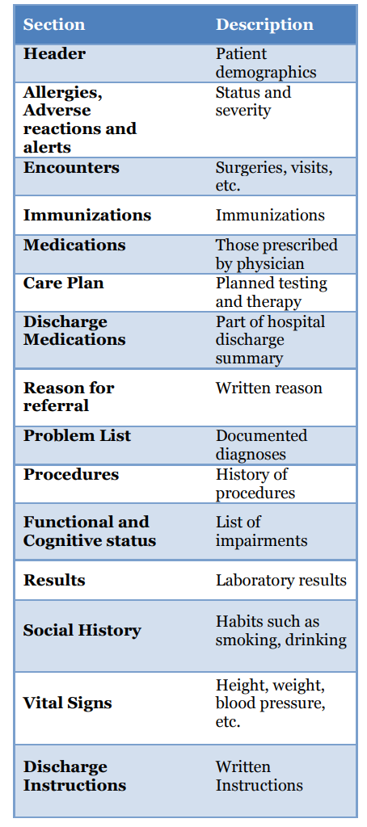

**Termonology standards**

**Logical Observations: Identifiers, Names and Codes (LOINC)**

• This is a standard for the electronic exchange of lab results transmitted to hospitals, clinics and payers. HL7 is a content standard, whereas LOINC is a vocabulary or terminology standard.

• The LOINC database has more than 72,000 terms (as of 2013) used for lab results. This is necessary as multiple labs have multiple unique codes that would otherwise not be interoperable.

• LOINC is divided into lab, clinical and HIPAA portions.

• The lab results portion of LOINC includes chemistry, hematology, serology, microbiology and toxicology.

• The clinical portion of LOINC includes vital signs, EKGs, echocardiograms, gastrointestinal endoscopy, hemodynamic data and others

. • The HIPAA portion is used for insurance claims.

• As an example: o The LOINC code for serum sodium is 2951-2; there would be another code for urine sodium. o The formal LOINC name for this test is: SODIUM:SCNC:PT:SER/PLAS:QN (component:property:timing:specimen:s cale)

• LOINC is accepted widely in the US (including federal agencies) and internationally. Large commercial labs such as Quest and LabCorp have already mapped their internal codes to LOINC. The main web site has a search engine to find LOINC codes.

• Other standards such as DICOM, SNOMED and MEDCIN have cross references (mapping) to LOINC.

• RELMA is a mapping assistant to assist mapping of local test codes to LOINC codes.

**RxNorm**

• RxNorm is the recommended standard for medication vocabulary for clinical drugs and drug delivery devices, developed by the National Library of Medicine (NLM).

• Each commercial drug vocabulary company e.g. First Data Bank provides medication concept identifiers to the NLM which are then mapped to the concepts in the RxNorm vocabulary.

• Rxnorm supports interoperability among organizations that deal with clinical drugs.

• RxNorm is the standard for e-prescribing and will support Meaningful Use.

• RxNorm encapsulates other drug coding systems, such as National Drug Code (NDC).

• The standard only covers US drugs at this point.

• The standard includes three drug elements: the active ingredient, the strength and the dose

• An example of RxNorm: 311642 (Methylcellulose 10 MG/ML Ophthalmic Solution).

**Systematized Nomenclature of Medicine: Clinical Terminology (SNOMED-CT)**

• SNOMED is the clinical terminology or medical vocabulary commonly used in software applications, including EHRs.

• SNOMED covers diseases, findings, procedures, drugs, etc.; a more convenient way to index and retrieve medical information.

• The vocabulary provides more clinical detail than ICD-9 and felt to be more appropriate for EHRs.

• SNOMED is also known as the International Health Terminology.

• This standard was developed by the American College of Pathologists. In 2007 ownership was transferred to the International Health Terminology Standards Development Organization www.ihtsdo.org . Chapter 6 Data Standards and Medical Coding| 169

• SNOMED will be used by the FDA and the Department of Health and Human Services.

• SNOMED will be required for stage 2 meaningful use to record family history, smoking history, transitions of care, hospital lab submission of reportable cases to public health agencies and submission of cancer cases to cancer registries.

• This standard currently includes about 1,000,000 clinical descriptions.

• Terms are divided into 19 hierarchical categories.

• The standard provides more detail by being able to state condition A is due to condition B.

• SNOMED concepts have descriptions and concept IDs (number codes).

Example: open fracture of radius (concept ID 20354001 and description ID 34227016).

• SNOMED CT also defines two types of relationships: o “Is a” connects concepts within the same hierarchy. Example: asthma “is a” lung disease. o “Attribute” connects concepts in different hierarchies. Example: asthma is associated with inflammation.

• SNOMED links (maps) to LOINC and the International Classification of Diseases (ICD) codes.

• SNOMED is currently used in over 40 countries.

• There is some confusion concerning the standards SNOMED and ICD; the latter is used primarily for research, quality improvement and reimbursement and the former for communication of clinical conditions.

• A study at the Mayo Clinic showed that SNOMED-CT was able to accurately describe 92% of the most common patient problems

• SNOMED-CT Example: Tuberculosis

o D E – 1 4 8 0 0

o . . . .

o . . . .

o . . . Tuberculosis

o . . Bacterial infections

o . E = Infectious or parasitic diseases

o D = disease or diagnosis

**MEDCIN®**

MEDCIN® was developed by Medicomp in the 1980s as a proprietary medical vocabulary. In 1997 it was released as a national standard.

MEDCIN® cross-references to many of the other standards already discussed. The nomenclature consists of about 270,000 clinical concepts organized into categories: symptoms, history, physical exam, tests, diagnosis and therapy. Each finding is associated with a numerical code, up to seven digits, so the results are structured or codified. Unlike SNOMED, MEDCIN® findings can link to symptoms, exam, therapy and testing. The knowledge base also includes 600,000 synonyms, allowing lookups under different terms. MEDCIN® is used by several EHR systems, to include the Department of Defense’s AHLTA.

The disadvantages of this system are the fact that there is a substantial learning curve to be able to search for all of the necessary MEDCIN® terms in order to create a completely structured note. Second, the note that is created tends to be poorly fluent and not like dictation (Figure 6.3). For that reason, Medicomp developed CliniTalk™ which is a voice to text option that means that a clinician can dictate and the end is structured data.

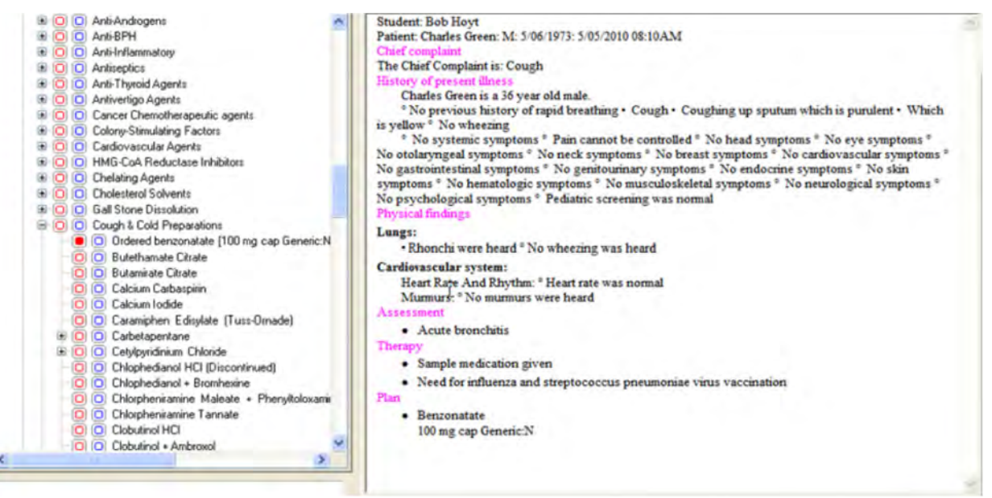

**Transport standards**

**EHR-Lab Interoperability and Connectivity Standards (ELINCS)**

**•** ELINCS was created in 2005 as a lab interface for ambulatory EHRs and a further “constraint” or refinement of HL7 standards.

• Traditionally, lab results are mailed or faxed to a clinician’s office and manually inputted into an EHR. ELINCS would permit standardized messaging between a laboratory and a clinician’s ambulatory HER.

• Standard includes:

o Standardized format and content for messages

o Standardized model for transport of messages

o Standardized vocabulary (LOINC)

• The Certification Commission for Healthcare Information Technology (CCHIT) has proposed that ELINCS be part of EHR certification.

• HL7 plans to adopt and maintain the ELINCS standard.

• California Healthcare Foundation sponsored this data standard.

**IEEE 11073**

• Data standards are needed for information to be sent from a medical device to an EHR or hospital information system.

• This is a fundamental standard for medical device connectivity and data exchange but is not widely used.

• HL7 version 2.x is used for data transfer but only supplies the syntax and not the semantics.

• Other initiatives are being developed to solve this interoperability problem:

o Integrating the Healthcare Enterprise Patient Care Device (IHE-PCD) Workgroup has developed use case profiles to support integration, alerts and implantable devices.

o Medical Device Plug and Play Interoperability Program’s Integrated Clinical Environment will develop a solution like IHE-PCD that will be based on IEEE 11073.

o IEC 80001 is standard under development to address devices in a networked environment.

o Continua Health Alliance focuses on home healthcare devices.

**National Council for Prescription Drug Programs (NCPDP)**

• NCPDP is a pharmacy related SDO for exchange of prescription related information.

• Script (v10.10) is for communication between physician and pharmacist.

• Other standards: batch standard, billing standard, formulary and benefit standard, prescription file transfer standard and universal claim form standard

**Accredited Standards Committee (ASC) X12**

• A standard for electronic data interchange (EDI) or the computer-computer exchange of business data

• Standard is used in healthcare, transportation, insurance and finance industries.

**Medical coding and reimbursement**

**Importance of Coding**: Coding is essential for reimbursement, as it is the language of reimbursement methodologies. It ensures providers receive the correct amount of reimbursement for services rendered and also provides data for various purposes such as disease registries, research, and quality improvement.

**Role of Professional Coders**: Professional coders require extensive knowledge of medical sciences to abstract clinical information from medical records and translate it into appropriate diagnostic and procedural codes. They play a crucial role in ensuring accurate reimbursement and data management.

**Certification**: Certification is becoming increasingly important for coding specialists. Organizations like AHIMA and AAPC offer various certification exams tailored to different levels of expertise and specialties in coding.

**ICD (International Classification of Diseases)**: Used for standardized descriptions of diseases and conditions. ICD-10-CM is currently used in the U.S., offering expanded and more specific coding compared to its predecessor, ICD-9-CM.

**CPT (Current Procedural Terminology)**: Published by the American Medical Association, it is used for procedural coding and reimbursement. Clinicians use CPT codes to obtain reimbursement for services performed.

**HCPCS (Healthcare Common Procedure Coding System)**: Contains Level I (CPT) and Level II codes used for reimbursement of supplies, equipment, and services not covered by CPT.

**Hospital Coding**: Involves assigning codes for inpatient and outpatient services, crucial for reimbursement and accuracy of hospital records.

**Physician Coding**: Physicians often use superbill templates listing common codes for their specialty, which are then entered into practice management systems for billing.

**ICD-10 Implementation**: The transition from ICD-9 to ICD-10 was a significant change, requiring updates in coding systems, databases, and standards to accommodate the expanded code set and new coding structure.

**Future trend**

Interoperable Resources (FHIR-pronounced FIRE), a new generation framework created by HL7, will combine the best features of HL7’s Version 2, and CDA standards and will be suited for a myriad of use cases. FHIR should be available for trial use by the end of 2013.34 Another example of an evolving and exciting standard is RESTful Health Exchange (RHEx), an open-source, open standard based on RESTful services for health information exchange.35 Lastly, Open ID Connect is a new standard that will help all types of Clients (webbased, mobile, etc.) connect to end users via an authentication server

**UNIT - IV**

**Healthcare Enterprise**

**Overview of Health Informatics:**

**Introduction**

the growth in the volume of medical knowledge and patient information that has occurred due to better understanding of human health has resulted in more treatments and interventions that produce more information. Likewise, the increase in specialization has also created the need to share and coordinate patient information. With the advent of the internet, high speed computers, voice recognition, wireless and mobile technology healthcare professionals today have many more tools available at their disposal. However, in general, technology is advancing faster than healthcare professionals can assimilate it into their practice of medicine.

Health Informatics is a rapidly evolving field that intersects information science, computer science, and healthcare. It focuses on the effective use of biomedical data, information, and knowledge for scientific inquiry, problem-solving, and decision-making aimed at improving human health. This field is crucial for managing the vast amounts of data generated by the healthcare industry, which is expected to continue growing significantly. Approximately 30% of the world's data comes from the healthcare sector, and this percentage is projected to rise to 36% by 2025. Despite the importance of data in healthcare, a significant portion of it is not utilized for making informed business decisions, highlighting the need for better data management and analytics within healthcare organizations.

Health Informatics encompasses several specialized areas, including:

* Public Health Informatics: Focuses on using information technology to educate the public and track current medical research. It involves designing and implementing new methods in the field.
* Organizational Informatics: Studies communication within medical organizations and the collection of data used by these organizations.
* Social Informatics: Investigates the social implications of computerization and how information technology affects society's perception of these systems.
* Clinical Informatics: Examines how information technology impacts clinical research and medical education, aiming to improve patient outcomes and advance medical research.

The field of Health Informatics is driven by the need for evidence-based medicine, quality improvement, data security, and patient accessibility. It plays a critical role in controlling and addressing public health concerns through the use of interprofessional teams. The future of Health Informatics looks promising, with advancements in technology and increasing investments in healthcare systems expected to enhance public healthcare accessibility and reliability.

Health Informatics is not just about technology; it's about how effectively technology is integrated into existing cultures, regulatory frameworks, and institutional workflows to improve healthcare delivery. The successful evolution of healthcare is determined by the integration of technology into these aspects, rather than solely by the technological capabilities themselves. This integration is crucial for advancing medical research, improving patient outcomes, and increasing the value of healthcare delivery.

**Data, Information, Knowledge, Wisdom Hierarchy**

Informatics is the science of information and the blending of people, biomedicine and technology. Individuals who practice informatics are known as informaticians or informaticists, such as, a nurse informaticist. There is an information hierarchy that is important in the information sciences, as depicted in the pyramid

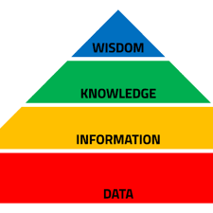

Health information technology provides the tools to generate information from data that humans (clinicians and researchers) can turn into knowledge and wisdom. Thus, enabling and improving human decision making with usable information is a central concern of informaticians.

**Key players in HI**

**Patients**

• Online searches for health information and research choice of physician, hospital or insurance plan

• Smartphone technology for test message reminders, health and fitness apps, internet access, etc.

• Web portals for storing personal medical information, making appointments, checking lab results, e-visits, drug refills, etc.

• Online patient surveys

• Online chat, blogs, podcasts, vodcasts and support groups and Web 2.0 social networking

• Personal health records

• Limited access to electronic health records and health information exchanges (HIEs)

• Telemedicine and home telemonitoring

**Physicians and Nurses**

• Online searches with PubMed, Google and other search engines

• Online resources and digital libraries

• Patient web portals, secure e-mail and evisits, telehomecare

• Physician web portals

• Clinical decision support, e.g. reminders and alerts

• Electronic medication administration record (eMAR) and bar coding medications

• Electronic health records (EHRs)

• Smartphones loaded with medical software and remote access to EHRs

• Telemedicine and telehomecare

• Voice recognition software

• Online continuing medical education (CME)

• Electronic prescribing

• Disease registries

• Picture archiving and communication systems (PACS)

• Pay-for-performance (P4P)

• Health information organizations (HIOs)

• E-research

• Electronic billing and coding Support Staff

• Patient enrolment

• Electronic appointments

• Electronic coding and billing

• EHRs

• Web-based credentialing

• Web-based claims clearinghouses

• Telehomecare monitoring

• Practice management software

• Secure patient-office e-mail communication

• Online educational resources and CME

• Disease registries

**Public Health**

• Incident reports

• Syndromic surveillance as part of bioterrorism program and Meaningful Use program criteria

• Establish link to all public health departments

• Geographic information systems to link disease outbreaks with geography

• Telemedicine

• Disease registries as part of EHRs or health information exchanges

• Remote reporting using mobile technology

**Federal and State Governments**

• Nationwide Health Information Network (HealtheWay)

• Financial support for EHR adoption and health information exchange

• Development of standards, services and policies for HIT

• Information technology pilot projects and grants

• Disease management

• Pay-for-performance

• Electronic health records and personal health records

• Electronic prescribing

• Telemedicine

• Broadband adoption

• Health information organizations (HIOs)

• Regional extension centers

• Health IT workforce development

**Medical Educators**

• Online medical resources for clinicians, patients and staff

• Online CME

• PubMed searches

• Telehealth via video teleconferencing, podcasts, etc**.**

**Insurance Companies (Payers)**

• Electronic claims transmission

• Trend analysis through data analytics

• Physician profiling

• Information systems for quality improvement initiatives

• Monitor adherence to clinical guidelines

• Monitor adherence to preferred formularies

• Promote claims-based personal health records and information exchanges

• Reduce litigation by improved patient safety through fewer medication errors

• Alerts to reduce test duplication

• Member of HIOs Hospitals

• Electronic health records

• Electronic coding and billing

• Information systems to monitor outcomes, length of stay, disease management, etc.

• eMARs

• Bar coding and radio frequency identification (RFID) to track patients, medications, assets, etc.

• Wireless technology

• E-intensive care units (eICUs)

• Patient and physician portals

• E-prescribing

• Member of health information organizations (HIOs)

• Telemedicine

• Picture archiving and communication systems (PACS)

**Medical Researchers**

• Database creation to study populations, genetics and disease states

• Online collaborative research web sites

• Electronic case report forms (eCRFs)

• Software for statistical analysis of data e.g. SPSS

• Literature searches with multiple search engines

• Randomization using software programs

• Improved subject recruitment using EHRs and e-mail

• Smartphones to monitor research

• Online submission of grants Technology Vendors

• Applying new technology innovations in the field of medicine: hardware, software, genomics, etc.

• Data mining

• Interoperability

• Certification

**organizations involved**

**Academic Organizations**

Institute of Medicine (IOM). One of the leading organizations in the United States to promote health information technology is the Institute of Medicine. It was established in 1970 by the National Academy of Sciences with the task of evaluating policy relevant to healthcare and providing feedback to the Federal Government and the public. In their two pioneering books To Err is Human (1999) and Crossing the Quality Chasm (2001), they reported approximately 98,000 deaths occur yearly due to medical errors. It is their contention that an information technology infrastructure will help the six aims set forth by the IOM: safe, effective, patient centered, timely, efficient and equitable medical care. The infrastructure would support “efforts to reengineer care processes, manage the burgeoning clinical knowledge base, coordinate patient care across clinicians and settings over time, support multidisciplinary team functioning, and facilitate performance and outcome measurements for improvement and accountability.” They also stress “the importance of building such an infrastructure to support evidence based practice, including the provision of more organized and reliable information sources on the internet for both consumers and clinicians and the development and application of decision support tools.”

“improve access to clinical information and support clinical decision making” • “Congress, the executive branch, leaders of health care organizations, public and private purchasers and health informatics associations and vendors should make a renewed national commitment to building an information infrastructure to support health care delivery, consumer health, quality measurement and improvement, public accountability, clinical and health services research, and clinical education. This commitment should lead to the elimination of most handwritten clinical data by the end of the decade.”

The IOM cited twelve information technology applications that might narrow the quality chasm

• Web-based personal health records

• Patient’s access to hospital information systems to access their lab and x-ray reports

• Access to general health information via the internet

• Electronic medical records with clinical decision support

• Pre-visit online histories

• Inter-hospital data sharing (health information exchange), e.g. lab results

• Information to manage populations using patient registries and reminders

• Patient - physician electronic messaging

• Online data entry by patients for monitoring, e.g. glucose results

• Online scheduling

• Computer assisted telephone triage and assistance (nurse call centers)

• Online access to clinician or hospital performance data.

**The Association of American Medical Colleges (AAMC).**

For more than twenty years the AAMC has been an advocate of incorporating informatics into medical school curricula and promoting health informatics in general. In their Better Health 2010 Report they made the following recommendations:

• Optimize the health and healthcare of individuals and populations through best practice information management

• Enable continuous and life-long performance-based learning

• Create tools and resources to support discovery, innovation and dissemination of research results

• Build and operate a robust information environment that simultaneously enables healthcare, fosters learning and advances science.

**Public-Private Organizations**

**Bridges to Excellence**. This is a program that rewards practitioners who provide superior patient care, with special emphasis on caring for patients with chronic conditions. This organization consists of employers, physicians, health plans and patients. They currently have multiple care recognition programs incentivized by bonuses: diabetes, cardiac care, congestive heart failure, coronary artery disease, cardiology, spine care, COPD, asthma, depression, hypertension, physician’s office technology, inflammatory bowel disease and medical home.

**eHealth Initiative.**  This is a non-profit organization promoting the use of information technology to improve quality and patient safety. Its membership includes virtually all stakeholders involved in the delivery of healthcare. This organization deals with multiple topics related to HIT and has a reports section that provides multiple articles on a variety of HIT topics. They also provide an annual survey of HIOs, starting in 2005. The 2013 survey results are available for download and discussed further in the chapter on health information exchange.

**Leapfrog**. Leapfrog is a consortium of over one hundred and seventy major employers seeking to purchase the highest quality and safest healthcare. Voluntary reporting by hospitals has made hospital comparisons possible and the results are reported on their website. They also have a hospital rewards program to provide incentives to hospitals that show they deliver quality care. One of their patient safety measures is the use of inpatient computerized physician order entry (CPOE) that will be covered in several other chapters.

**Markle Connecting For Health.** This organization is a public-private collaboration operated by the Markle Foundation and funded partially by the Robert Wood Johnson Foundation. With over 100 stakeholders, its primary mission is to promote interoperable HIT. They published Common Framework: Resources for Implementing Private and Secure Health Information Exchange that helps organizations exchange information in a secure and private manner, with shared policies and technical standards. The Common Framework with nine policy guides and seven technical guides is available free for download on their web site.

**National eHealth Collaborative** **(NeHC).** This government-civilian-consumer collaborative took over in early 2009 when the American Health Information Community (AHIC) was dissolved. They are charged with prioritization of HIT standards to promote interoperability. They create value cases and refer those for harmonization of standards and once accepted they will be adopted by the certification organizations such as the Certification Commission for Health Information Technology (CCHIT). NeHC is a cooperative agreement partner of the Office of the National Coordinator for Health IT (ONC) and the US Department of Health and Human Services (HHS). NeHC University is an online education program to inform stakeholders about multiple HIT issues, created in 2011.

**Healthcare Information Technology Standards Panel (HITSP)**. This panel was a public-private partnership established in 2005 by the Department of Health and Human Services (DHHS). HITSP was charged by the ONC to harmonize standards-based on use cases derived from AHIC requirements. Each interoperability specification is a suite of documents that provides a roadmap of how standards and specifications will answer the requirements of the use case. For instance, specifics of the standard for using the Continuity of Care Document (CCD) were released as C32 in March 2008 with a detailed explanation of the technical aspects. The CCD is discussed further in the chapter on data standards. Their contract with the government was terminated in April 2010 and their function was largely replaced by the HIT Standards Sub-Committee discussed in a following section.

**The Certification Commission for Healthcare Information Technology (CCHIT)** was created by HIMSS and multiple other healthcare professional organizations. Its goals are to: reduce the risk of health information technology (HIT) investment by physicians; ensure interoperability of HIT; enhance the availability of HIT incentives and accelerate the adoption of interoperable HIT. Their initial step was to certify ambulatory electronic health records. By mid-2011 they certified the following categories of HIT: ambulatory EHRs, inpatient EHRs, Health Information Exchanges, Emergency EHRs, Cardiovascular Medicine EHRs, Child Health EHRs, Behavioral Health EHRs, Dermatology, Long Term/Post-Acute Care EHRs, Home Health EHRs and E-prescribing. EHRs that have received certification are listed on the web site. The Commission consists of 20 commissioners from a variety of backgrounds and numerous volunteers in their work groups.

CCHIT decided they would offer different levels of EHR certification so more EHRs would qualify for Medicare or Medicaid reimbursement under ARRA:

(1) CCHIT certified® 2011 and 2014, a comprehensive certification that would actually exceed federal standards and includes a usability score,

(2) ONC-ATCB Certification will test EHRs against Meaningful Use regulations, hosted by the National Institute of Standards and Technology (NIST),

(3) EHR vendors can elect to be certified by both CCHIT and ONCATCB criteria, and

(4) EHR Alternative Certification for Healthcare Providers (EACH) that certifies homegrown technology created by healthcare organizations and not vendors.

As of mid-2013 seventy one ambulatory EHRs were CCHIT certified using 2011 criteria, to include usability ratings. Multiple EHR-related resources are also available. Certification is quite expensive as noted by one reference.

**National Committee on Vital and Health Statistics (NCVHS)** is a public advisory body to the Secretary of Health and Human Services. It is composed of 18 members from the private sector who are subject matter experts in the fields of health statistics, electronic health information exchange, privacy/security, data standards and epidemiology. They have been very involved in advising the Secretary in matters related to eHealth Exchange (Nationwide Health Information Network).

**US Federal Government** The federal government has maintained that information technology is essential to improving the quality of medical care and containing costs; two important aspects of healthcare reform. It is a major financer of health care with the following programs: Medicare/Medicaid, Veterans Health Administration, Military Health System, Indian Health Service and the Federal Employees Health Benefits Program. It is therefore no surprise that they are heavily involved in health information technology and stand to benefit greatly from an interoperable Nationwide Health Information Network. Agencies such as Medicare/Medicaid and the Agency for Healthcare Research and Quality conduct HIT pilot projects that potentially could improve the quality of medical care and/or decrease medical costs. The federal government has recognized the importance of technology in multiple areas and as a result has a new federal chief technology officer and chief technology officer for HHS.

**American Recovery and Reinvestment Act (ARRA).** Without a doubt, the most significant recent governmental initiative that affected the field of Informatics was the ARRA. This legislation impacts HIT adoption, particularly EHRs, as well as training and research. ARRA had five broad goals:

(a) improve medical quality, patient safety, healthcare efficiency and reduce health disparities;

(b) engage patients and families;

(c) improve care coordination;

(d) ensure adequate privacy and security of personal health information;

(e) improve population and public health. Title IV and XIII of ARRA, known as the Health Information Technology for Economic and Clinical Health (HITECH) Act was devoted to funding of HIT programs

• Privacy and HIPAA changes; to be discussed in chapter on privacy

• The National Telecommunications and Information Administration’s Broadband Technology Opportunities Program. This will fund the National Broadband plan discussed in the chapter on telemedicine

• USDA’s Distance Learning, Telemedicine and Broadband Program

• Indian Health Services HIT programs

• Social Security Administration HIT programs

• Veterans Affairs (VA) HIT programs

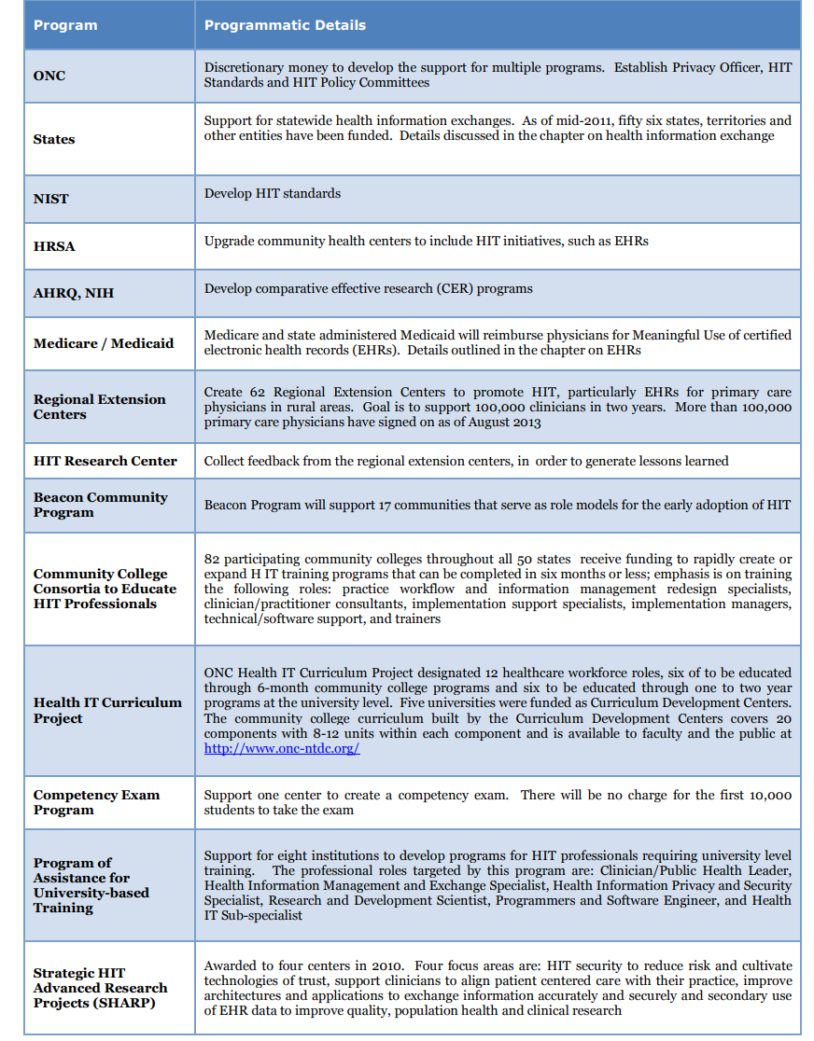

**Health Resources and Services Administration (HRSA)** is part of HHS with the primary mission of assisting medical care for the underserved and uninsured in the United States, particularly in rural areas. They support federally qualified health centers (FQHCs) and rural health centers (RHCs). As noted in the section on the ARRA, HRSA will support grants for community health centers to include the installation and upgrades of health information technology. They have been a long term grant supporter of telemedicine. On their site they post a variety of health-related data in their HRSA data warehouse. A variety of searchable topics are presented with the ability to present as a table, chart, map or report.

**National Institute of Standards and Technology (NIST)** is a physical science laboratory that is part of the U.S. Department of Commerce, and serves to promote and verify measurements and standards. This federal agency makes EHR testing recommendations. The following is a list of some of the pertinent publications related to EHRs:

• (NISTIR 7741) NIST Guide to the Processes Approach for Improving the Usability of Electronic Health Records

• (NISTIR 7742) Customized Common Industry Format Template for Electronic Health Record Usability Testing

• (NISTIR 7743) Usability in Health IT: Technical Strategy, Research, and Implementation

• (NISTIR 7769) Human Factors Guidance to Prevent Healthcare Disparities with the Adoption of EHRs

**State Governments and HIT** There are a variety of state-based HIT initiatives, evaluating the adoption of technologies such as electronic health records, HIE and e-prescribing. State Medicaid offices are anxious to conduct pilot projects aimed at reducing costs and/or improving quality of care. The State Alliance for e-Health was created in 2006 in an attempt to navigate the issues of best practices, policies and adoption obstacles. Support for the Alliance is from ONC as well as a private-public advisory committee. They have three task forces: health information protection, health care practicehealth information communication and data exchange taskforces. Their highest priorities are e-prescribing and the privacy and security of health information.

**International Governments and HIT** This chapter focuses primarily on US health informatics, but the reality is that this is an important and emerging field worldwide. Other countries have less expensive and less fragmented healthcare systems but they also have to deal with aging populations and rising chronic diseases. Meanwhile, technology continues to evolve unabated and in the case of mobile technology is quite affordable. They are therefore looking for healthcare solutions using cost-effective health information technology. Issues such as IT interoperability among European nations and certification are challenges all countries face. In the case of Europe and the European Union they refer to Health IT as eHealth and IT as information and communication technology (ICT).

**Barriers**

**Inadequate time**. This complaint is a common thread that runs throughout most discussions of technology barriers. Busy clinicians complain that they don't have enough time to read, learn new technologies or research vendors. They are also not reimbursed to become technology experts. They usually have to turn to physician champions, local IT support, Regional HIT Extension Centers or others for technology advice.

**Inadequate information**. As already pointed out earlier in the chapter, clinicians need information, not data. Current HIT systems are data rich but information poor. This is discussed in detail in the Healthcare Data, Information and Knowledge chapter.

**Inadequate expertise and workforce**. In order for the United States to experience widespread HIT adoption and implementation, it will require education of all healthcare workers. According to Dr. Blumenthal (previous National Coordinator for HIT) the United States will need approximately 51,000 skilled health informaticians over the next five years to create, install and maintain HIT.

**Inadequate cost and return on investment data**. The literature on the economic aspects of HIT adoption and implementation is mixed and based on different assumptions and methods. In a 2013 article by Bassi and Lau they posit that such an evaluation should have six components: having a perspective, options for comparison, time frame, costs, outcomes and comparison of costs and outcomes for each option. Examples of high quality economic reviews are available in their paper.

**High cost to adopt**. It is estimated that a Nationwide Health Information Network (eHealth Exchange) will cost $156 billion dollars over five years and $48 billion annually in operating expenses. Technologies such as picture archiving and communications systems (PACS) and electronic health records are also very expensive. The ARRA will help underwrite the initial purchase of some technologies but long term support will be a different challenge. There is still limited evidence that most technologies will actually save money. This is discussed in more detail in the chapter on electronic health records.

**Lack of interoperability**. Electronic health records and the NwHIN cannot share medical information until data standards are adopted and implemented nationwide. Interoperability and data standards are covered in more detail in other chapters.

**Change in workflow**. Significant changes in workflow will be required to integrate technology into the inpatient and outpatient setting. As an example, clinicians may be accustomed to ordering lab or x-rays by giving a handwritten request to a nurse who actually places the order. Now they have to learn to use computerized physician order entry (CPOE). As with most new technologies, older users have more difficulty changing their habits, even if it will eventually save time or money. Poor usability is also an important impediment to good workflow and we will address this in the chapter on electronic health records. There is also some evidence that young physicians are spending more time on the computer and less with the patient which is disconcerting.75 According to Dr. Carolyn Clancy, the director of AHRQ:

**“The main challenges are not technical; it’s more about integrating HIT with workflow, making it work for patients and clinicians who don’t necessarily think like the computer guys do”**

**Privacy concerns**. The Health Insurance Portability and Accountability Act (HIPAA) of 1996 was created initially for the portability, privacy and security of personal health information (PHI) that was largely paper-based. HIPAA regulations were updated in 2009, and again in 2013, to better cover the electronic transmission of PHI or (ePHI). This Act has caused healthcare organizations to re-think healthcare information privacy and security. This will be covered in more detail in the chapter on privacy and security. In the past few years there have been a series of privacy breaches and stolen identities in healthcare organizations, thus adding to the angst.

**Legal issues**. The Stark and Anti-kickback laws prevent hospital systems from providing or sharing technology such as computers and software with referring physicians. Exceptions were made to these laws in 2006, as will be pointed out in other chapters. This is particularly important for hospitals in order to share electronic health records and e-prescribing programs with clinician’s offices. Many new legal issues are likely to appear.

**Behavioral change**. Perhaps the most challenging barrier is behavior. In The Prince by Machiavelli, it was stated “there is nothing more difficult to be taken in hand, more perilous to conduct, or more uncertain in its success, than to take the lead in the introduction of a new order of things.”

Dr. Frederick Knoll of Stanford University described the five stages of medical technology acceptance:

(1) abject horror,

(2) swift denunciation,

(3) profound skepticism,

(4) clinical evaluation, then, finally

(5) acceptance as the standard of care. It is unrealistic to expect all medical personnel to embrace technology. In 1962, Everett Rogers wrote Diffusion of Innovations in which he delineated different categories of acceptance of innovation:

• The innovators (2.5%) are so motivated; they may need to be slowed down

• Early adopters (13.5%) accept the new change and teach others

• Early majority adopters (34%) require some motivation and information from others in order to adopt

• The late majority (34%) require encouragement to get them to eventually accept the innovation

• Laggards (16%) require removal of all barriers and often require a direct order

It is important to realize, therefore, that at least 50% of medical personnel will be slow to accept any information technology innovations and they will be perceived as dragging their feet or being Luddites.

**HIT hype versus fact**. The Gartner IT Research Group describes five phases of the hype-cycle that detail the progression of technology from the technology trigger to the peak of inflated expectations to the trough of disillusionment to the slope of enlightenment to the plateau of productivity.81 Figure 1.8 shows the hype curve for a variety of IT technologies for 2013.

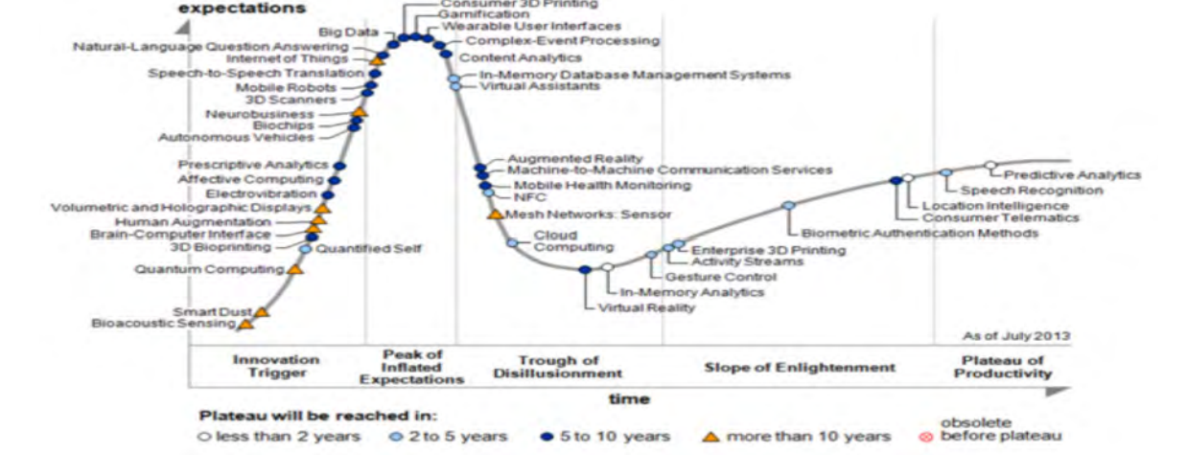

**Programs, organizations and career**

**Health Informatics Academic Programs**

One of the best sites to review the various health informatics programs in the United States can be found on the American Medical Informatics Association’s web site. Health informatics programs can be degree, certificate, fellowship and short courses. Most programs are part of a university, community college, medical or nursing school and others may be part of a health related organization such as the National Library of Medicine. Courses can be online, taught in a classroom setting or both. Health informatics degree programs are available as follows: associate degree, undergraduate degree, Master’s degree, PhD degree or part of another degree program. Master’s degrees may be focused on applied training or readying students for a research career. The AMIA program listings will give the reader an idea of how many programs are available in North America and in which category. In addition, it will provide an idea as to the rapid growth of health informatics programs in a relatively short period of time.69 Another resource is the Health Informatics Forum that lists international health informatics programs.96 As of February 2013, community colleges participating in ONC’s Community College Consortia to Educate Health IT Professionals have trained 17,523 individuals.56 The majority of health informatics students in the past have come from healthcare fields. With the current economy and the new monies from the ARRA, IT professionals from other industries are enrolling in health informatics training programs.

**Health Informatics Organizations**

The following organizations are considered among the most important and influential.

**AMIA**

• Founded in 1989 by the merger of the American Association for Medical Systems and Informatics, the American College of Medical Informatics and the Symposium on Computer Applications in Medical Care

• In 2006 it became a member of the Council of Medical Specialty Societies

• As of 2013 AMIA has greater than 4000 members from clinical, technical and research sectors

• They support five main domains: translational bioinformatics, clinical research informatics, health informatics, consumer health informatics and public health informatics

• They offer a Clinical Informatics Board Review course and a practice exam

• They also offer 10 x 10 courses • Members are from 65 countries

• They frequently collaborate with AHIMA, discussed later

• Developed the clinical informatics board certification process with the first exam in late 2013

• Web site includes a career center, academic programs and education, policy positions, news, events, fellowships, grants, and an enewsletter

• Membership includes subscription to the Journal of the American Medical Informatics Association (JAMIA)

• Opportunity to join a working group (20) to discuss issues and formulate white papers

• Annual national symposium in the fall as well as a spring Congress

**International Medical Informatics Association (IMIA)**

• Began in 1967 but became officially an independent endorsed organization in 1989

• Membership consists of national, institutional, affiliate members and honorary fellows

• AMIA is the US representative to the IMIA

• IMIA supports the triennial World Congress on Medical and Health Informatics, known as Medinfo

• IMIA supports multiple working groups and special interest groups

• Official journals: International Journal of Medical Informatics, Methods of Information in Science, and Applied Clinical Informatics

**European Federation for Medical Informatics (EFMI)**

• Organization began as a collaboration of 10 countries in 1976

• Members represent the informatics society of their country

• In 2013, thirty countries have joined the Federation

**Asia Pacific Association for Medical Informatics (APAMI)**

• APAMI is an extension of the IMIA in the Asia Pacific region that began in 1994

• Current members include informatics societies from: Australia, China, Hong Kong, Indonesia, Japan, Korea, Malaysia, New Zealand, Philippines, Singapore, Taiwan, Thailand and Vietnam

**Health Informatics in Africa (HELINA)**

• Supports the IMIA vision in Africa

• Current members include informatics societies from: Ethiopia, Cameroon, Malawi, Ivory Coast, Nigeria, Mali, South Africa, Togo and Ghana

**Canada’s Health Information Association (COACH)**

• IMIA representation in Canada since 1975

• As of 2013 they have more than 1500 members

• Comprehensive services to members, such as professional development

**Healthcare Information and Management Systems Society (HIMSS)**

• Founded in 1961

• As of 2013 has about 50,000 individual members and 570 corporate members

• Annual symposium with more than 20,000 attendees

• Professional certification

• Educational publications, books and CDROMs

• Web conferences on health informatics topics

• HIMSS Health IT Body of Knowledge resource site

• HIMSS Analytics is a subsidiary that provides data and analytic expertise

• Surveys on multiple topics

**American Health Information Management Association (AHIMA)**

• Founded in 1928 for medical records librarians and in 1991 became known as the AHIMA

• As of 2013 has more than 67,000 members

• It began as a medical records association but now includes any healthcare worker involved in information and data management. It offers seven credentials related to four areas: Coding, HIM, privacy and analysis

• “AHIMA supports the common goal of applying modern technology to and advancing best practices in health information management”

• AHIMA web site has an excellent HIT resource section, CME and certification information, and books available from AHIMA Press

• AHIMA Journal and Perspectives in Health Information Management are available on their web site at no cost68 Alliance for Nursing Informatics (ANI)

• Combines 25 separate nursing informatics organizations

• As of 2007 has more than 3,000 members

• Sponsored by both the AMIA and HIMSS

• Provides a collaborative group for consensus about nursing informatics

**American Telemedicine Association**

• Established in 1993 to promote telecommunications technology

• Has transitioned to telemedicine, telehealth or eHealth

• Mission is to promote remote access to medical care through telemedicine technology • Web site has a variety of educational resources and telemedicine forms

• Official journal is Telemedicine and eHealth

**Health Informatics Careers**

The timing is excellent for a career in health informatics. With the emphasis on increasing adoption of electronic health records and health information exchange, coupled with support from the HITECH Act there has been tremendous interest in health informatics. Healthcare organizations and HIT vendors will be looking for workers who are knowledgeable in both technology and healthcare. They are looking for experienced individuals who can hit the ground running, in order to direct implementation of multiple types of HIT such as EHRs and new standards such as ICD-10. The Department of Labor estimates that there will be 4% growth in the demand for trained health informatics specialists in multiple areas in the private, federal and military sectors. This estimate may be too conservative, given the fact that postings for health IT jobs tripled between 2009 to 2012.104 Informaticians will be needed to design, implement and govern many new technologies arriving on the medical scene, as well as train users. Informatics training programs will need to continue the process of designing curricula based on actual needs from the industry. It is anticipated that government reimbursement for EHRs and support for health information exchange will only increase the need for skilled HIT workers. The Health Informatics Forum, HIMSS, American Nurse Informatics, Health IT News, AHIMA and the AMIA web sites list multiple interesting health IT jobs. According to the HIMSS Jobmine site the job titles in highest demand in decreasing order were: IT technical management, analyst, healthcare informatics, systems analyst and project management.105 Other job categories include: nurse and physician informaticists, information directors, chief information officers (CIOs) and chief medical information officers (CMIOs). Recruiting organizations also maintain multiple listings for health IT jobs. There are a wide variety of jobs available in the informatics realm. The following are just a few of the known positions in a healthcare organization:

**Chief Medical Informatics Officer (CMIO)** is usually a physician but could be a nurse who generally reports to the Chief Information Officer (CIO), Chief Executive Officer (CEO) or Chief Medical Officer (CMO). This individual usually works with the CIO to develop a strategic IT plan and to help with the implementation of technologies by clinical staff. CMIOs are less IT oriented and more oriented towards overcoming the barriers to adoption and they provide feedback and education to their staff. They evaluate new technologies that may transform healthcare and along with the CIO they help develop policies that affect privacy and security. They commonly have a Master’s degree in one of the information sciences. In 2002 HIMSS developed a Certified Professional in Health Information Management Systems (CPHIMS) certification and exam. This is primarily aimed at professionals who work in healthcare. In 2011 1651 individuals were certified (68% nurses and 18% physicians).They must have a bachelor’s degree and 5 years of information management experience (2 years in healthcare) or a graduate degree and 3 years of information management experience (2 years in healthcare).

**Nurse Informaticist (NI)** is a nurse who can be the CMIO or can be an individual who works in the nursing department, IT department or is dual hatted. There are three million nurses in the United States, compared to about 800,000 physicians so they are a large pool of knowledge workers. Most nurses are trained to think in terms of systems and process improvement. They are therefore extremely valuable for project management, IT systems managers, data analysts, technology adoption, implementation and training. Nurse Informaticians have had a certification exam since 1995 and published their Scope and Standards in 2008. To take the certification exam, candidates must have an RN degree, at least 2 years of clinical practice, 30 hours of continuing education in informatics in the prior year and other qualifications. In 2010 there were 729 certified nurse informaticists.

**Clinician Informatician (CI)** is a clinician who may have formal training with a variety of degrees or simply may have extensive on the job experience and an aptitude for technology. As a result, they are usually early adopters and clinician champions who help the clinical staff in a healthcare organization understand and accept transformational technologies.

AMIA helped establish the medical subspecialty of clinical informatics. In September 2011 it was announced that clinical informatics was an approved subspecialty, sponsored by the American Board of Preventive Medicine and the American Board of Pathology. The certification will be available to physicians who have a primary specialty designated through the American Board of Medical Specialties (ABMS). There will be a period of 5 years in which physicians can be “grandfathered” in without formal informatics education. In the 2009 March/April issue of JAMIA, the core content for this new specialty is spelled out.108-109 The plan is to make board certification exams available starting in the Fall of 2013. The following are admission requirements for certification:

• ABMS member board certification in a current specialty 28 |Chapter 1 Overview of Health Informatics

• Attendance at an accredited in the US or Canada or one deemed satisfactory to the Board

• Current license holder

• Completion of one of the following pathways (acceptable through 2017; after that candidates will need to complete 24 months in an accredited clinical informatics program):

o Three years of practice (in the past 5 years) in the clinical informatics field; at least 25% of a FTE

o If a candidate has completed less than 24 months in a non-accredited program, candidates must submit evidence of the training program.

o Similar certification is being discussed for nurses, pharmacists, PhDs and others. Further details are available at this reference

In mid-2013 AMIA provided more detail about a proposed Advanced Interprofessional Informatics Certification. The goal would be to provide certification for those individuals who are not eligible for the subspecialty of clinical informatics. A majority of workers in the health informatics field and members of AMIA are not eligible for certification in clinical informatics so this advanced certification should have broad appeal. The certification should have the same requirements as the subspecialty certification and should be at the graduate level

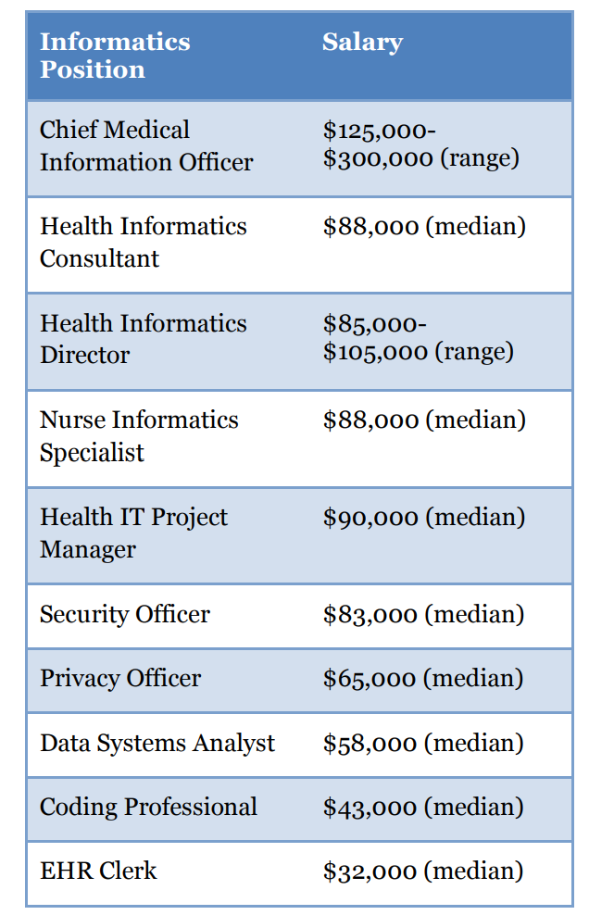

**HI Resoruces**

Because of the rapidly changing nature of technology it is difficult to find resources that are current. It is also difficult to find resources that are not overly technical that would be appropriate for the health informatics neophyte. There are numerous excellent journals, ejournals and e-newsletters that contain articles that discuss important aspects of health information technology. Because health informatics is gaining popularity in the field of medicine many excellent articles can also be found in major medical journals that do not normally focus on technology. As an example, Health Affairs, a bimonthly health policy journal features web exclusives, blogs and e-newsletters of interest to informaticians. Furthermore, several informatics-related web sites link to the major national and international health informatics print and online journals.

**Books**

• Handbook of Biomedical Informatics. Wikipedia Books. 2009

• Guide to Health Informatics. Enrico Coiera. 2003

• Biomedical informatics: Computer Applications in Health Care and Biomedicine. EH Shortliffe and J Cimino 2006

• Medical Informatics: Concepts, Methodologies, Tools and Applications. J Tan. Four Volumes. 2009

• Health Informatics: An Interprofessional Approach. Nelson R, Staggers N. 2013

**Journals**

• **Journal of the American Medical Informatics Association** is the bimonthly journal of the AMIA. It features peer reviewed articles that run the gamut from theoretical models to practical solutions. The journal is included in the AMIA membership and is most appropriate for medical and IT professionals.

**• International Journal of Medical Informatics** is an international monthly journal that covers information systems, decision support, computerized educational programs and articles aimed at healthcare organizations. In addition to standard articles, they publish short technical articles and reviews.

• **Journal of Biomedical Informatics** was formally known as Computers and Biomedical Research. Its editor is Dr. Ted Shortliffe and the emphasis of this bimonthly journal is bioinformatics.

• **Journal of AHIMA** is published 11 months of the year for its members to stay current in health information management-related issues.

• **Computers, Informatics, Nursing (CIN)** is a bimonthly print journal targeting the nursing professional. Also offers PDA downloads, RSS feeds and a newsletter.

**E-journals**

• **BMC Medical Informatics and Decision Making** is an open-access free online journal publishing peer-reviewed research articles. This journal is part of BioMed Central, an online publisher of 188 online free full text journals. Because it is an open-access model it allows for much more rapid review and publication, a plus for informatics journals.

• **The Open Medical Informatics Journal** is another open-access free online journal that publishes health informatics research articles and reviews. Bentham Science publishes 89 online and print journals as well as 200 online open-access journals. An abstract is available online and the full text pdf copy is downloadable.

• **Journal of Medical Internet Research (JMIR)** is an independent open-access online journal that publishes articles related to medicine and the internet. The articles are free to read in an html format but there is a cost to download articles in a pdf format or to become a member.

• **Electronic Journal of Health Informatics (eJHI)** is an Australian-based international open access electronic journal that offers open access (no fee) to both authors and readers.

• **Applied Clinical Informatics** is the fee-based e-journal for the International Medical Informatics Association (IMIA) and Association of Medical Directors of Information Systems (AMDIS). Its first issue appeared in early 2010.

• **Perspectives in Health Information Management** is the open-access research peerreviewed e-journal for AHIMA, published four times a year.

• **Online Journal of Public Health Informatics** is an open source general interest peer reviewed e-journal published three times annually.

**Informatics-Related E-newsletters**

• **iHealthBeat** is a free daily e-mail newsletter on health information technology published as a courtesy by the California Healthcare Foundation. It is also available through RSS feeds, Twitter and they offer frequent podcasts.

• **HealthCareITNews** is available as a daily online, RSS feed or print journal. It is published in partnership with HIMSS and reviews broad topics in HIT. They also publish the online e-journals NHINWatch, MobileHealthWatch and Health IT Blog.

• **eHealth SmartBrief** is a free newsletter emailed three times weekly. In addition to broad coverage of HIT, they offer RSS feeds, blogs, reader polls and job postings.

• **Health Data Management** offers a free daily e-newsletter, in addition to their comprehensive web site. The web site offers 20 channels or categories of IT information, webinars, whitepapers, podcasts and RSS feeds.

**Online Resource Sites**

**• InformaticsEducation.org** resource center was created to augment this textbook. The site augments this book with valuable web links organized in a similar manner as the book chapters. It also includes links to excellent informatics newsletters and journals.

• **Agency for Healthcare Research and Quality Knowledge Library** is another excellent resource with over 6,000 articles and other resources that discuss health information technology related issues.

• **HIMSS Health IT Body of Knowledge** is a new site to introduce readers to more than 25 topic categories. Articles, tools and guidelines are offered by HIMSS and other resources.

• **HealthIT.gov** is the official web site for the Office of the National Coordinator for Health Information Technology. The site provides valuable information about HIT initiatives and progress throughout the United States.

• **AHIMA HIM Body of Knowledge™** is a searchable database of HIM-oriented material from AHIMA and governmental sources.

• **Family Medicine Digital Resources Library** was created by Dr. Tom Agresta and supported by the Society of Teachers of Family Medicine to promote Informatics education of Family Medicine physicians. In early 2010 they posted 14 presentations that are available to the public.

• **OpenClinical** is a not-for-profit organization that supports advanced knowledge management in the following areas: background, research clinical, commercial and public. The site includes resources that are pertinent to many chapters in this textbook.

• **Health Informatics Forum** is an international forum and blog. In addition the site offers the massive open online course (MOOC) on health informatics free of charge. This is the same course administered by many community colleges under the HITECH Act funding.

**Informatics Blogs**

• **HealthIT Buzz Blog** provides HIT updates from the HHS Office of the National Coordinator for Health Information Technology (ONC) .

• **Informatics Professor Blog** and provides the insights of Dr. William Hersh, Professor and Chair of the Department of Medical Informatics & Clinical Epidemiology, Oregon Health & Science University. 144 Additional health informatics resources are posted on his website.

• **The Health Care Blog** is hosted by Matthew Holt and considered to be “a free-wheeling discussion of the latest healthcare developments" to include health information technology

**• E-CareManagement** focuses on chronic disease management, technology, strategy, issues and trends. Content is posted by Vince Kuraitis, a HIT consultant for Better Health Technologies.

• **Health Informatics Forum**, administered by Dr. Chris Paton, is an international social network for health informatics professionals and students with extensive web links.

• **Biological Informatics** was created by Marcus Zillman to compile multiple biomedical informatics sites (100+) into one, as well as a blog.

• **HealthTechtopia** compiles the top 50 health informatics blogs. It is subdivided into General Health Informatics, Anatomy & Physiology, Information Science and Information Technology, Computer Science, Statistics and Radiology and Medical Imaging.

• **Biomedexperts** is a free social network for biomedical researchers. They have created groups based on what articles have been published by the scientists involved. The claim to have profiles on 1.8 million biomedical researchers from 190 countries. Profiles were generated from the last 10 years of PubMed. In this manner research networks can be created.

**UNIT – V**

**Health Information privacy and security**

**Introduction**

The Health Insurance Portability & Accountability Act (HIPAA) passed in 1996 laid much of the groundwork for the privacy and security measures being adopted within healthcare today. The original intent was to direct how patient data was used and made available when patients switched physicians or insurers, and included two major rules covering privacy and security of that data. The American Recovery and Reinvestment Act of 2009 (ARRA), and the HITECH Act which accompanied it, both brought about changes designed to improve privacy and security measures required by modern technologies and closed loopholes within the original law.

**Basic security principles**

According to the International Information Systems Security Certification Consortium (ISC2), among others, there are three pillars of information security (confidentiality, availability, and integrity) that are fundamental to protecting information technology solutions such as health information technology (HIT)

Security measures are instituted collectively to meet one or more of these primary goals, with the end result being one where confidentiality, availability and integrity are all covered.

• **Confidentiality** refers to the prevention of data loss, and is the category most easily identified with HIPAA privacy and security within healthcare environments. Usernames, passwords, and encryption are common measures implemented to ensure confidentiality.

**• Availability** refers to system and network accessibility, and often focuses on power loss or network connectivity outages. Loss of availability may be attributed to natural or accidental disasters such as tornados, earthquakes, hurricanes or fire, but also refer to man-made scenarios, such as a Denial of Service (DoS) attack or a malicious infection which compromises a network and prevents system use. To counteract such issues, backup generators, continuity of operations planning and peripheral network security equipment are used to maintain availability.

• **Integrity** describes the trustworthiness and permanence of data, an assurance that the lab results or personal medical history of a patient is not modifiable by unauthorized entities or corrupted by a poorly designed process. Database best practices, data loss solutions, and data backup and archival tools are implemented to prevent data manipulation, corruption, or loss; thereby maintaining the integrity of patient data.

**Security Tools and Solutions**

Information security is in many ways analogous to physical security techniques employed at a residence or place of employment. Some solutions are used to deter and prevent access, such as locks on doors and windows, use of shrubs, bright or motion-sensitive lighting, video cameras, guard shacks, fencing and gates. Similarly, business networks and information resources are protected by access control lists (ACL), firewalls, intrusion detection and intrusion prevention systems, authentication systems, and monitoring and auditing services designed to mimic their physical counterparts around the building or home. Instead of a key, one uses a username and password or token to gain access. The firewall acts as the barrier designed to keep out those who do not belong. Intrusion systems take the place of video surveillance; and similar to footage used for evidence in a crime, these systems can help forensics investigators track an intrusion back to its source. Monitored services imitate physical alarm systems, and forensics specialist track intruders who may unwittingly leave a trail of evidence, ultimately leading to real-world arrests and convictions. One real-world example of this is the case of Army PFC Bradley Manning, who leaked untold quantities of classified data to WikiLeaks founder Julian Assange, and then failed to cover the digital tracks which led investigators to the evidence used to try him. It is the correlation between the physical and the electronic that much of this chapter builds on.

**Organizational Roles**

Information security roles and responsibilities can vary widely from organization to organization depending on size, industry, compliance mandates and laws, technology initiatives, maturity, private or public status, and even profit model. Policy regarding information security practices is often set by chief information officers (CIOs), chief technology officers (CTOs), information technology (IT) directors or similar; often with input from chief medical informatics officers (CMIOs), HIPAA compliance officers, or the like. Depending on resources, the information technology teams may consist of network, system administration, security and data personnel, or could be the very same technical staff relied upon for all office or clinic IT needs. No matter the titles, this supporting staff is often tasked to defend key networks, and patient data from risk, and assist with any investigations resulting from a data breach.

**Authentication** **and identity management**

These are the chief tenants of authentication, and are supported by photo identification, biometrics, smart card technologies, tokens, and the old standard; user name and password. Authenticating users, patients and staff is essential for providing system access, ensuring only those with need to know have access, protecting important data, and lending legal credence to actions and records.

**Basic Authentication**

The devices and methods people use to gain access to systems, data, and web solutions vary depending upon the sensitivity of the data, the capabilities of the systems, resource constraints - both technical and monetary, and the frequency of access. All of the methods discussed here rely on what is known as two or multi-factor authentication. The factors fall into three categories – something one knows, something one has, or something that one is.18 The most basic of these is the tried and true username and password combination still employed by a majority of users today, combining two things that a user knows. Another option is utilizing a grid card, smart card, USB token, one time password (OTP) token, or OTP service in combination with something a user knows, such as a passphrase or PIN. All of these rely on something one has; either a card, token, or in the event of the OTP service, some mechanism to view a message that contains the one time use character string or passphrase to be used. By combining something a user has with something he or she knows, twofactor authentication occurs. Figure 8.1 contains a selection of these authentication tools, showing a grid card, smart card, OTP card and OTP smartphone service application.

**Single Sign On**

Anyone who has used a computing device more than a few times quickly learns that most systems, whether physical workstations or web based solutions, require some method of authentication, typically in the form of a username and password. Before long, users find themselves with a growing list of usernames and passwords for any number of devices, email accounts, banking access, social networks, retail websites, and even a few dedicated to work resources.

This is the practice known as single sign on (SSO), and when implemented correctly, it allows users to access a variety of disparate systems using one set of stored credentials. SSO can be utilized for more than system and network access, enabling users to authenticate to the web and software as a service (SaaS) solutions as well. One common example of SSO is a service offered by Google partner organizations which use Google Apps, such as Gmail, Google Docs, and Calendar. The partner organizations, perhaps a small business or school, “control usernames, passwords and other information used to identify, authenticate and authorize users for web applications that Google hosts” through the SSO solution, offering seamless transitions between local resources and hosted applications.

Although the above example employs a username and password, other mechanisms such as smart cards, tokens and even biometrics are capable of offering SSO capability for a wide range of client, software, and web-based solutions. This permits the use of a single token or card used for workstation or network access to also connect with web-based application and other solution software without additional user logon.

**Smart Cards**

These portable card devices carry vital patient information and have a self-contained processor and memory. Typically smart cards are read by direct physical contact with the card reader or through remote radio frequency interface. Examples of the patient data that can be stored on the card are patient identity verification, complete patient demographics, allergies, medications, known medical issues, surgeries and procedures, additional patient information such as implanted devices, and insurance information. Some of the advantages are cost, ease of use, portability and durability, and ability to support multiple applications. Security features can include encrypted patient information as well as digital or biometric signatures and personal identification (PIN) numbers or passwords. Some of their drawbacks are a lack of standardization or integration, as well as cost of physician buy in, and new technology apprehension. Smart Cards have the potential to be a valuable tool for patients, providers, and insurers alike if they prove to provide positive identification, deliver a secure and portable inclusive health record, and accelerate the entire patient experience from registration to treatment.

**Digital Signature**

Part of the problem that arises when shifting from hard copy medical record documentation to electronic format is signing new records. Beyond the obvious improvement in discerning the signatory compared to a handwritten signature, there needs to be some additional contrivance that provides some assurance that the digital signature is valid and that it was placed by the person it is attributed to. In the case of patient records, this digital signature also acts as the legal signature of the practitioner. As such it can serve as non-repudiation for electronic messaging and records access for audit purposes and in some cases meets compliance controls or measures for identity management. The strength of this technology is such that email correspondence containing an electronic signature is sufficient to prove that the originator and the signatory are one in the same. This is possible because the originator is the only one with the unique key required to produce the electronic signature. The example shown in

**Certificate Based Encryption**

An advanced form of digital certificate technology is certificate based encryption. Whereby a digital signature is used to provide assurances and non-repudiation from a given party, encryption is intended to completely obscure the contents of a message, preventing compromise of sensitive information in the event that a message is intercepted en route. Although the algorithms used for encrypting data are somewhat complex, the practical applications are easily understood. By having pre-shared public keys, individuals can send correspondence to each other taking comfort in the knowledge that the contents are protected from prying eyes. In the case of encryption though, it is the recipient’s public key that is used by the sender to encrypt the message, not the sender’s. Since the recipient has the lone private key, only he or she will be able to decipher the message and view the contents.

Given the constraints placed upon organizations trying to meet HIPAA, Sarbanes-Oxley Security (SOX), or Payment Card Industry (PCI) compliance mandates, encryption provides a much-needed layer of security designed to protect the most sensitive of data. example where this could be employed is correspondence involving patient records. As an alternative to de-identification of a patient record, a record could be sent with all identifying data to a qualified recipient using the data encryption mechanism described above. This type of data protection mechanism is permitted for sensitive data in motion, as described in the Health Information Technology for Economic and Clinical Health (HITECH) Act and is a component of secure messaging through the Direct Project as described in the chapter on health information exchange.

**Digital & Information Rights Management**

Beyond identifying the user and authenticating against systems and web solutions, users can also be controlled for roles, permissions, and access in fine detail. Digital Rights Management (DRM) and Information Rights Management (IRM) are related data access concepts that are gaining in adoption as compliance initiatives and risk management practices take hold in organizations across many industries. One common application of DRM and IRM functionality is with content management systems, such as Microsoft SharePoint or EMC Documentum product lines. While it is essential to secure sensitive health data from unauthorized access, it is increasingly important to limit any unnecessary access to patient records. DRM and IRM allow organizations to limit user or system access to data only when it is needed, place time constraints upon said access, limit how and where data can be viewed, modified and moved, as well as create records for auditing and forensics purposes. The DRM and IRM mechanisms employed on an organizational content management system (CMS), electronic health record (EHR) product data repositories and the like allow for setting granular rights permissions to the user level. Records of the activity can be used for compliance audits, but also serve as evidence in cases where unauthorized access is suspected, an example of which is a case in Florida where three non-medical hospital employees accessed medical records of accident victims and forwarded this information to a law referral service. Though the three individuals were eventually caught, this activity could have been prevented if DRM and IRM controls had been in place.

**Biometric Authentication**

In addition to authentication mechanisms which rely on something the user has (e.g. grid card or USB token), there are now biometric authenticators based on physical user identifiers. Biometric authentication typically uses a fingerprint, retinal scan, or voice imprint, although iris, vein and even heart rhythm based ECG scans have been proposed as solutions in recent years. When combined with passphrases or the tokens, cards, and OTP solutions discussed previously, a two or multifactor authentication solution can be employed. The key take-away from the examples of two factor authentication is the difficulty these present to would-be attackers or data thieves, as it greatly increases the complexity required for user access over a simple username and password combination. Although usernames and passwords are not likely to fade away anytime soon, increased adoption of other more secure methods is almost certain, particularly in the face of increased data breaches, attacks, and even industry regulations.

**Data security in the cloud and client**

Recent changes in technology and product models have thrown an additional element into the mix for organizations to contend with; which type of solution to choose. The traditional practice management or electronic health record solution is based on software that runs on local network infrastructure and is delivered via a client terminal using terminal services or loaded on a workstation. Hospitals and practices maintain the system and equipment locally and work with vendors for troubleshooting, software change requests, and upgrades. The latest contender is software as a service (SaaS), used to deliver the solution via a Web browser. Oftentimes, SaaS solutions rely on another new technology, cloud computing, to store data and provide the back office computing power traditionally handled by servers and network storage devices. In this type of solution, the hospital contracts with a vendor to provide all of the services which are delivered to the end user. Each solution type has security risks and vulnerability for HIT workers to contend with; whether it is a stolen laptop, missing backup media, or a SaaS service compromise. Deciding which solution is appropriate for an organization is decided by a number of factors 204 | Chapter 8 Health Information Privacy and Security that require careful deliberation and planning. Products like the Application Security Questionnaire (ASQ) from HIMSS can assist organizations performing their own research and planning for HIT solutions. The ASQ is a vendor-neutral, seven page capabilities checklist that hospitals, practices or medical organizations can request that software

